TITLE: ML LAB – 11: Natural Language Processing (NLP)
Student Name: Mahir Desai
Roll No: 23FE10CSE00345
------------------------------------------------
AIM
Implement basic Natural Language Processing (NLP) techniques, including text preprocessing, tokenization, stemming, lemmatization, and feature extraction using Bag of Words and TF-IDF.
------------------------------------------------
Experiment 1: Text Preprocessing
a) Load sample text and perform Lowercasing and Tokenization
import nltk
import string
from nltk.corpus import stopwords
from nltk.tokenize import word_tokenize
text = "Natural Language Processing (NLP) is amazing! It allows machines to understand human language."
text_lower = text.lower()
tokens = word_tokenize(text_lower)
Original Text:
Natural Language Processing (NLP) is amazing! It allows machines to understand human language.
Lowercased Text:
natural language processing (nlp) is amazing! it allows machines to understand human language.
Tokens:
['natural', 'language', 'processing', '(', 'nlp', ')', 'is', 'amazing', '!', 'it', 'allows', 'machines', 'to', 'understand', 'human', 'language', '.']
b) Remove Punctuation and Stopwords
tokens_no_punct = [word for word in tokens if word not in string.punctuation]
stop_words = set(stopwords.words('english'))
tokens_no_stop = [word for word in tokens_no_punct if word not in stop_words]
Tokens without punctuation:
['natural', 'language', 'processing', 'nlp', 'is', 'amazing', 'it', 'allows', 'machines', 'to', 'understand', 'human', 'language']
Tokens without stopwords:
['natural', 'language', 'processing', 'nlp', 'amazing', 'allows', 'machines', 'understand', 'human', 'language']
Experiment 2: Word Normalization
a) Perform Stemming and Lemmatization
from nltk.stem import PorterStemmer, WordNetLemmatizer
stemmer = PorterStemmer()
stemmed_tokens = [stemmer.stem(word) for word in tokens_no_stop]
lemmatizer = WordNetLemmatizer()
lemmatized_tokens = [lemmatizer.lemmatize(word) for word in tokens_no_stop]
processed_text = " ".join(lemmatized_tokens)
Stemmed Tokens:
['natur', 'languag', 'process', 'nlp', 'amaz', 'allow', 'machin', 'understand', 'human', 'languag']
Lemmatized Tokens:
['natural', 'language', 'processing', 'nlp', 'amazing', 'allows', 'machine', 'understand', 'human', 'language']
Processed Text:
natural language processing nlp amazing allows machine understand human language
Experiment 3: Feature Extraction
a) Apply Bag of Words (Count Vectorizer)
from sklearn.feature_extraction.text import CountVectorizer
documents = [text, processed_text]
count_vectorizer = CountVectorizer()
bow = count_vectorizer.fit_transform(documents)
print("Bag of Words Feature Names:\n", count_vectorizer.get_feature_names_out())
print("\nBag of Words Matrix:\n", bow.toarray())
Bag of Words Feature Names:
['allows' 'amazing' 'human' 'is' 'it' 'language' 'machine' 'machines'
'natural' 'nlp' 'processing' 'to' 'understand']
Bag of Words Matrix:
[[1 1 1 1 1 2 0 1 1 1 1 1 1]
[1 1 1 0 0 2 1 0 1 1 1 0 1]]
b) Apply TF-IDF Vectorization
from sklearn.feature_extraction.text import TfidfVectorizer
tfidf_vectorizer = TfidfVectorizer()
tfidf = tfidf_vectorizer.fit_transform(documents)
print("TF-IDF Feature Names:\n", tfidf_vectorizer.get_feature_names_out())
print("\nTF-IDF Matrix:\n", np.round(tfidf.toarray(), 2))
TF-IDF Feature Names:
['allows', 'amazing', 'human', 'is', 'it', 'language', 'machine',
'machines', 'natural', 'nlp', 'processing', 'to', 'understand']
TF-IDF Matrix:
[[0.23 0.23 0.23 0.32 0.32 0.46 0. 0.32 0.23 0.23 0.23 0.32 0.23]
[0.27 0.27 0.27 0. 0. 0.55 0.39 0. 0.27 0.27 0.27 0. 0.27]]
Experiment 4: Visualization
a) Visualize TF-IDF Scores for Original Text
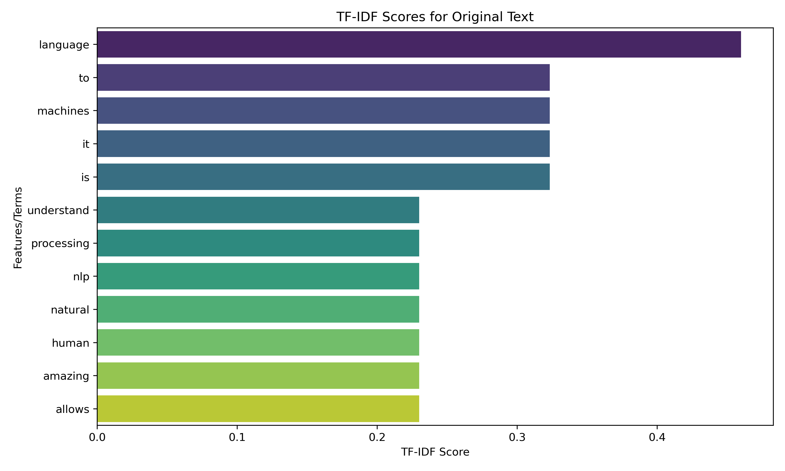
------------------------------------------------
Answers:
1. Lowercasing promotes consistency, while Tokenization splits sentences into meaningful words.
2. Removing stopwords and punctuation extracts core semantic meaning and reduces noise.
3. Stemming truncates words to its root, while Lemmatization maps words back to logical dictionary lemmas.
4. Bag of Words considers raw counts, whereas TF-IDF scales term importance inversely against document frequency.

